First Announcement

12th Biennial International Conference

Advanced Carbon NanoStructures

(ACNS’2015)

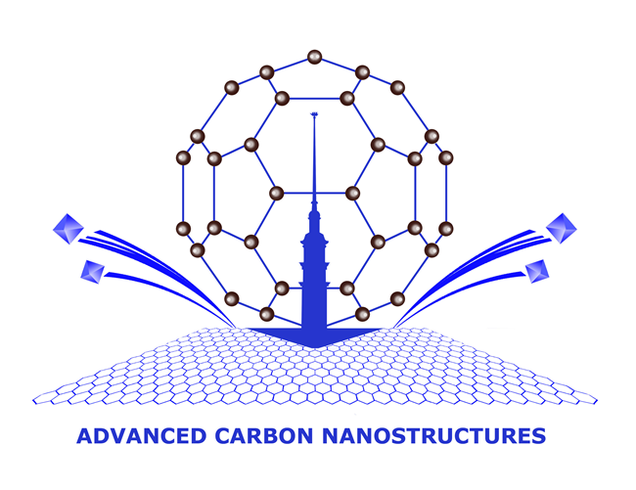

June 29 – July 3, 2015

St.Petersburg, Russia

Abstracts deadline – 15 March, 2015

Organizers

Ioffe Physico-Technical Institute, Russia

St.Petersburg Nuclear Physics Institute, Russia

National Research Center "Kurchatov Institute", Russia

St.Petersburg State Institute of Technology (Technical University) Russia

Scope
The program will traditionally include lectures by invited speakers, oral presentations and several poster sessions. The lectures and oral presentations will generally concentrate on the most recent advances in the following areas:

- Materials

  - Fullerenes

Carbon Nanotubes

Graphene
  - Nanodiamond particles
  - Carbon onions
  - Nanographite
  - Nanoporous carbon

- Phenomena

  - Synthesis
  - Electronic properties
  - Magnetic properties
  - Optical properties
  - Mechanical properties
  - Phase transitions

And

- Technology of all materials mentioned above
- Theory and computer simulation of carbon nanostrucrtures
- Methods for characterization of nanocarbons
- Applications of carbon nanostructures
Preliminary list of invited speakers

1. Jean-Charles Arnault, CEA LIST, France
Hydrogenated nanodiamond: a versatile tool for biomedical applications

2. Franco Cataldo, Osservatorio Astrofisico di Catania, Italy

3. Luis Echegoyen, University of Texas at El Paso, USA
Buckyball Maracas: the importance of size, shape and electronic complementarity between the ecapsulated clusters and the carbon cages of endohedral fullerenes

4. Dominik Eder, Institut für Physikalische Chemie, Germany
Nanocarbon-inorganic hybrids for sustainable energy applications

5. Yuhei Hayamizu, Tokyo Institute of Technology, Japan

6. Anatoli Krestinin, Institute of Problems of Chemical Physics, Russia

7. Vasily Lebedev, National Research Centre "Kurchatov Institute", B.P.Konstantinov Petersburg Nuclear Physics Institute, Russia
Biocompatible water-soluble endometallofullerenes: peculiarities of self-assembly in aqueous solutions and the ordering under magnetic field applied

8. Levon Piotrovskiy, Institute of Experimental Medicine, Russia

9. Victor Ral'chenko, Prokhorov General Physics Institute, Russia
Nano- and microcrystalline diamond films and structures for photonics grown by a microwave plasma chemical vapor deposition

10. Ping Sheng, HKUST, Hong Kong, China

11. Shangfeng Yang, University of Science and Technology of China, China
Endohedral and exohedral functionalization of Fullerenes

Organizing Committee of ACNS’2015

Ioffe Institute
26 Polytechnicheskaya st.
St.Petersburg 194021, Russia
Tel: +7(812) 292 73 77; Fax: +7(812) 297 00 73
e-mail: info@acns2015.org
www.acns2015.org
INFORMATION

Biennial International conference "Advanced Carbon Nanostructures" ACNS’2015 the same as ACNS’2013 continues the series of the joined conferences that started in 2011 when the 10th Biennial International Workshops "Fullerenes and Atomic Clusters" and the 4th International Symposiums "Detonation Nanodiamonds: Technology, Properties and Applications" were unified into single event "Advanced Carbon Nanostructures 2011" (ACN’2011).

The scope of the conference includes new carbon nanostructures, members of nanocarbon family - fullerenes, carbon nanotubes, graphene, carbide derived carbon, onions, nanographite and nanodiamonds.

ACNS'2015 is the international forum for the exchange of information on the latest progress in carbon nanostructures. The scientific program consists of both oral and poster presentations as well as lectures by invited keynote speakers who survey areas of major interest.
General topics include synthesis and technology, physical properties, chemistry of carbon nanostructures as well as their main applications for industry, biology and medicine.

Progress in modern nanotechnologies requires development of new, and refinement of already available methods of diagnostics. This is why we also arrange the conference school for young scientists "Advanced carbon nanostructures and methods of their diagnostics" which will be held in the course of the ACNS'2015.

St Petersburg is both a scientific and a cultural center. It is a beautiful city designed and built by Russian and Western architects. It is often called "the Venice of the North". As usual along with the Scientific Session, a Social Program is planned.

The Organizers are pleased to welcome members of the world nanocarbon community to St Petersburg during the beautiful time of white nights.

Organizing committee
Alexander Ya. Vul' - Ioffe Institute, Russia
(Conference Chair)
Sergey V. Kidalov- Ioffe Institute, Russia
(Chair)
B.B. Chaivanov - National Research Center "Kurchatov Institute", Russia
V.F. Ezhov - National Research Centre "Kurchatov Institute", B.P.Konstantinov Petersburg Nuclear Physics Institute, Russia
A.V. Kirillin- Russian Foundation for Basic Research, Russia
P.S. Kop'ev - Ioffe Institute, Russia
V.V. Kveder - Institute of Solid State Physics, Chernogolovka, Russia
V.T. Lebedev - National Research Centre "Kurchatov Institute", B.P.Konstantinov Petersburg Nuclear Physics Institute, Russia
N.V. Lisitsyn - St Petersburg State Institute of Technology, Russia
O.M. Nefedov - Branch of Chemistry and Material Sciences, Russian Academy of Sciences
M.Yu. Romanovsky - Department of General Physics, Russian Academy of Science
S.A. Tsyganov - Russian Foundation for Basic Research, Russia
A.G. Zabrodsky - Ioffe Institute, Russia

International Advisory Committee
F. Banhart Strasbourg University, France
J. Davidson Vanderbilt University, USA
M. Dresselhaus MIT, USA
L. Echegoyen University of Texas at El Paso, USA
T. Enoki Tokyo Institute of Technology, Japan
D. Gruen Argonne National Laboratory, USA
D. Guldi University of Erlangen-Nurnberg, Germany
R. Kalish Israel Institute of Technology, Israel
W. Kraetschmer Max-Plank Institute, Germany
H. Kroto Florida State University, USA
E. Osawa Nagoya University, Japan
H. Shinohara Nagoya University, Japan
F. Wudl University of California, USA
Programme Committee

Marina V. Baidakova - (Co-Chair), Ioffe Institute, Russia
Artur T. Dideikin - (Co-Chair), Ioffe Institute, Russia
V.L. Aksenov - National Research Centre "Kurchatov Institute", B.P.Konstantinov Petersburg Nuclear Physics Institute, Russia
A.E. Aleksensky - Ioffe Institute, Russia
A.S. Artjomov - Lebedev Physical Institute, Russia
V.Yu. Dolmatov - Federal State Unitary Enterprise "Special Design and Technological Office "Technolog",
Russia
Yu.S. Grushko - National Research Centre "Kurchatov Institute", B.P.Konstantinov Petersburg Nuclear Physics Institute, Russia
A.V. Eletskii - Russian Research Center "Kurchatov Institute", Russia
M. Korobov - Moscow State University, Russia
S.V. Kozyrev - Center for Advanced Studies of
St Petersburg State Polytechnical University, Russia
A.V. Krestinin - Institute of Problems of Chemical Physics, Russia
I.I. Kulakova - Moscow State University, Moscow, Russia
V.L. Kuznetsov - Boreskov Institute of Catalysis, Russia
L.B. Piotrovsky - Institute of Experimental Medicine, Russia
O.A. Shenderova - International Technology Center, USA
A.M. Shikin - St Petersburg State University, Russia
V.I. Sokolov - Institute of Organoelement Compounds, Russia,
V.M. Titov - Institute for Hydrodynamics, Russia
A.P. Vozniakovskii - Federal State Unitary Enterprise Scientific Research Institute for Synthetic Rubber, Russia
A.Ya.Vul’ - Ioffe Institute, Russia

