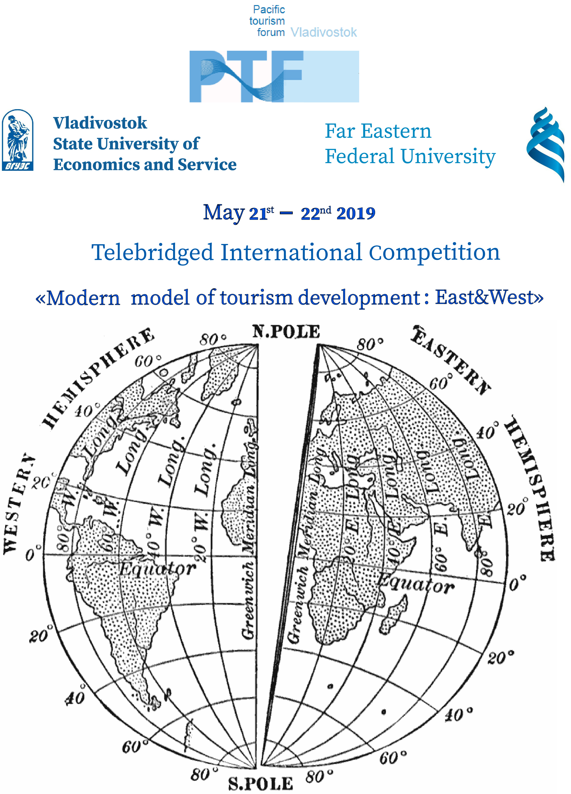
May 2021
Dear Colleagues,
We’d like to invite you to take part in the Telebridged International Competition "Modern model of tourism development: East&West", held within the framework of the Pacific tourism forum

Competition organizers: Vladivostok State University of Economics and Service, Far Eastern Federal University.
Competition co-organizers: Tourist Information Centre of Primorsky Territory, with the support of the Government of Primorsky Territory and the Expert Council for Tourism under the Governor of the Primorsky Territory.
The goal of the Competition - to draw attention to the current problems and peculiarities of tourism development, to discuss prospects for its development in each region.
Competition sections:
* Information technology in tourism;
* New projects in tourism;
* Promo video for tourists of my city;
* Tourism support policies;
* International youth tourism: new forms and prospects for development.
Three winners in each section receive Pacific Tourist Forum diplomas. In addition, every presenter gets a Pacific Tourist Forum certificate, confirming his participation in international event.
Competition language: English
Participation format: Online presentation
Deadline for submission of applications: May 16th
Deadline for submission of the report presentations: May 25th
Presentation should be sent in Microsoft Power Point-compatible format
Works are not reviewed, THEY ARE non-refundable and THEY may be rejected without explanation.

Materials for the competition should be sent to the address of the coordinator:

Kononov Artem – artem.kononov@yahoo.com

Wechat: +7 (924) 1311138, Whatsapp 7 (950) 2804772

Specify "International competition submission" in the email’s subject line. All materials should be sent as attachments.
Competition is planned to be held in the first decade of June 2020. Final date and time of airing will be determined with the respect of the time zones of alleged participants.
Sincerely,
Competition Organizing Committee

